Elżbieta Köster

ORCID: <https://orcid.org/0009-0008-9613-8608>

Montabaur (Germany)

email: [ElzbietaKoester@gmx.de](mailto:ElzbietaKoester@gmx.de)

**Application of the Social Network Analysis Method to the Reconstruction of a Social and Kinship Network Based on the Marriage Registers of the 18th Century Parish of Żarki**

**Abstract**

The purpose of this article is to describe a practical application of the Social Network Analysis (SNA) method in demographic and historical research. It was used to reconstruct the social and kinship network of the 18th-century parish of Żarki on the basis of marriage registers. The SNA method is still rarely used by Polish historians. The article uses mathematical graph models, created on the basis of scenarios, to better analyze the role of two basic concepts (nodes and kinship) in the social network, resulting in the specification of the central role of kinship in the network. The relationships described in the article are those of marriage, testimony and kinship. The Gephi network visualization program was used to generate a digraph of the parish of Żarki (1718–1720), as an example of a small town community.

**Keywords**

Żarki parish, 18th century, SNA, social network analysis, social structure, social network, nodes, relationships, directed node, undirected node, reciprocal node, marital relationship, witness relationship, kinship/affinity relationship

**Introduction**

“Through error you come to the truth!” (Fyodor Dostoyevsky)

Social networks as a real-world phenomenon have existed and continue to exist, regardless of the research being done on them. Niall Ferguson writes, “We live ... in the network age,”[1] emphasizing that there is a growing awareness of this phenomenon in the modern world. However, in order to understand the mechanisms of today’s networks, it is necessary to study those that existed in the past, even the smallest ones.[2]

Trying to reconstruct the social network of the 18th century, especially that of a small town with an urban and rural character, is a great challenge for the historian. This is due to the difficulty of obtaining various types of source material (documents, diaries, accounts, ecclesiastical and secular population registers, tax censuses, etc.), on the basis of which it is possible to reconstruct the structures of human relationships. Sometimes the researcher is left only with parish registers, which are classified as demographic sources. This type of source makes it possible, to a certain extent,[3] to reconstruct an objective reality fixed in time and space. The text of the article is an attempt to demonstrate a practical application of the method of Social Network Analysis (SNA) to the reconstruction of the social and kinship network of small-town society in the 18th century, on the basis of marriage registers.

The Social Network Analysis method has its roots in sociology, where it is used to analyze contemporary communities. Based on questionnaires and surveys with appropriately formulated questions, social networks are reconstructed. However, it is emphasized that this is only a fragment of a particular world and that interpersonal interactions are more complex and multi-layered. A historian consulting 18th century parish registers is aware that they were not written with the idea that they would one day be used to reconstruct social networks using the SNA method. Nevertheless, the undoubted advantage of this method is its ability to structure and analyze large amounts of data and to capture possible processes that are difficult to detect with traditional methods. One of the methods used in Social Network Analysis is the mathematical graph. The advantage of the graph is its flexibility and ease of adaptation to different fields of study.[4] However, the SNA’s mathematical approach to graph formation can cause difficulties.

The subject of the study is the 18th-century population of the Żarki parish, which until 1795 was administratively part of the Kraków Voivodeship and the Lelów District, and was owned by the Męcinski family of Kurozwęki under the Poraj Coat of Arms.[5] The social and kinship network of this parish will be reconstructed on the basis of the marriage records.[6] In pre-statistical demography marriage registers are considered the most reliable of the three series (marriages, baptisms and deaths).[7] The Żarki parish registers from this period have been inventoried and are kept in the Diocesan Archives in Częstochowa.[8] The research aims at capturing two generations in the period from 1718 to 1795 in the form of a directed network. The network reconstructed in this way will be subjected to a variety of research analyses available with the SNA method: statistical methods (calculation of arithmetic means, weights or correlations), and analysis in terms of the whole network—its density, cohesion, centralization, group formation or clique. In addition, the following are analyzed in terms of the “ego-network” unit: prestige, position in the group, or placement in relation to the network as a whole; analysis of social life, including in relation to demographic characteristics: the age of the newlyweds, their age at first marriage, and age at second marriage,[9] the mobility of the newlyweds, the choice of partners and witnesses, or the social structures from which partners or witnesses were chosen. In addition, a network reconstructed in this way can reveal the nuances of relationships between the population, as well as the interactions between different social groups such as the petty gentry, town owners, millers, or the urban poor. In addition to its advantages, social network analysis also has disadvantages. First, it should be remembered that the reconstructed network is only a subjective fragment of a past reality, based on induction and deduction. In order to visualize such a construct, appropriate software is required. In this research the program Gephi 0.10 is used.[10]

The purpose of this article is to describe a practical approach to the use of the SNA method in the reconstruction of a directed social network. After a brief introduction, issues of the conjugal relationship in both ecumenical law and secular tradition are discussed. After an introduction to the main concepts of the SNA method (social network, node, directed relationship, undirected relationship), the concept of its application in network reconstruction is outlined. The concept is presented in a step-by-step manner using model examples to illustrate the key role of relationships in networks. The article concludes with an example of the social network of the parish of Żarki for the years 1718–1720. The motivation for writing the article is the desire to popularize the SNA method for demographic and historical research.

**Origins of the Social Network Analysis Method**

The list of contributors, authors, and researchers in Social Network Analysis (SNA) is long. The examples given are subjective in nature and also reflect the concept of the article. Georg Simmel published a paper in 1908 entitled “The Quantitative Determination of Groups.” In it he outlined his research on the variable interactions between the individual and social circles/groups. He states that a dyad is the smallest element (two individuals and the connection between them) of such a community, where there are already variable relationships (like them or dislike them; know them or don’t know them; son–father or father–son, etc.). If, on the other hand, we extend its structure to include another individual, a triad is formed. A third individual who joins the group can either alleviate or aggravate conflicts, thereby triggering new behavioral mechanisms. Historically, Simmel is considered one of the pioneers and founders of Social Network Analysis.[11]

Jacob Moreno contributed to the development of SNA by being the first to introduce graphical charts, which he called sociograms, and the method by which he measured social relationships, sociometry (*Who shall survive*?, 1934).[12] The term ‘social structure’ in the context of networks was first used by the sociologist and anthropologist Alfred Radcliffe-Brown in 1940.[13] John A. Barnes, after a fourteen-month study of the community in Bremnes, formulated the concept of a network in his work *Classes and Committees in a Norwegian Island Community* (1954). He imagined it as a collection of nodes connected by lines, where the nodes could represent individuals or groups, while the lines outlined the interaction between them.[14]

The 1960s and 1970s saw the development of graph theory[15] and computer science. These disciplines were instrumental in the development of the methods of social network analysis. At the end of the 20th century, SNA was not widely used by researchers in other sciences outside of sociology and related disciplines. In contrast, the 21st century is already being referred to as the age of networks to emphasize that everything around us is interconnected. Increasing computerization and the technology to support it have made it possible to analyze more and more data, which has positively influenced the growing interest in the SNA method for various research projects.[16]

**Use of the SNA Method: State of Research**

In 2020, Cezary Kuklo noted “the need for new research methods in the historian’s toolbox, such as Social Network Analysis (SNA).”[17] Jerzy Marek Minakowski is credited with the greatest achievement in using the tools of the SNA method.[18] Dorota Gregorowicz, reviewing Michał Salamonik’s book *Mieszczańska kariera w szlacheckiej Rzeczypospolitej? Francesco De Gratta i jego social network* (A Bourgeois Career in the Noble Republic? Francesco De Gratta and His Social Network) commented on the “ego-network” method chosen by the author to better characterize the main character.[19] The network context using the SNA method to present the main research areas of Professor Edward Wlodarczyk was used in the article “Działalność naukowa profesora Edwarda Włodarczyka w świetle publikacji autorskich (1973–2020) (“The Academic Work of Professor Edward Wlodarczyk in the Light of his Publications (1973–2020)”).”[20] Dariusz Chojecki and Radoslaw Gaziński created a social and family network of Huguenots living in Szczecin at the end of the 18th century using baptismal registers. The network they constructed is of an undirected nature.[21]

However, the use of marriage registers for social network analysis is rarely used in demographic research. Aleksandra Dul in her article “Życie towarzyskie dziewiętnastowiecznej wiejskiej parafii. Analiza sieci społecznych” (Social Life of a Nineteenth-Century Rural Parish: An Analysis of Social Networks)[22] created a picture of the social network of a 19th century community, on the basis of which she attempted to describe the residents of the Ivanovice parish. The network she built took the form of a directed graph, thanks to which all the relationships retained their information in the connections.

**The Main Concepts of Social Network Analysis**

Graph theory adapted for Social Network Analysis influenced the development of its terminology. These new disciplines developed primarily in English-speaking culture.[23] Below are some basic definitions.

Graph:

*A graph G consists of a non-empty finite set V(G) of elements called vertices, and a finite family E(G) of unordered pairs of (not necessarily distinct) elements of V(G) called edges; the use of the word “family” permits the existence of multiple edges. We call V(G) the vertex set and E(G) the edge family of G*.”[24]

Network:

*A network is, in its simplest form, a collection of points joined together in pairs by lines. In the nomenclature of the field a point is referred to as a node or vertex and a line is referred to as an edge.*[25]

Social network:

*A social network is a structure composed of a set of entities, some of whose members are connected by a set of one or more relations.*[26]

*A social network consists of a set of nodes (sometimes referred to as actors or vertices in graph theory) connected via some type of relations, which are also called ties, links, arcs, or edges*.[27]

The purpose of the above summary is to show the similarities and differences between the concepts cited.

All three definitions speak of two sets, where for graphs they are abstract elements, for networks they are sets of points and lines, and for social networks they are sets of nodes (which can be called actors) and relationships (familiarity relationships, hierarchy relationships, contact relationships, etc.). This mathematical world has been applied to social research. In social network analysis, a social network, or graph as a network structure, is defined as a set of nodes connected by various types of relationships.

Since graph theory is, so to speak, the basis of the above definitions, the following are its key concepts, which are also used in SNA.

The mathematical form of graph notation is as follows:

G[raph]= (V[ertices], E[dge])[28] (1)

This states that a graph consists of two sets: vertices and edges, whereby the set of vertices is a non-empty set, while the set of edges can be an empty set. In addition, one element from the edge set connects a minimum of two elements from the vertex set.[29]

Depending on the direction of the edges, the graphs are either directed or undirected.[30] A directed graph defines a directed edge (arrow, arc) that connects an ordered pair of vertices, where one will be called the source (outgoing) vertex and the other the target (incoming) vertex. An undirected graph is characterized by an undirected edge (line) that connects an ordered pair of vertices, where each vertex can be a source vertex as well as a target vertex.[31]

This mathematical world has been applied to social research. In social network analysis, a social network, or graph as a network structure, is defined as a set of nodes connected by different types of relationships.[32] Nodes can represent individuals, groups, institutions, organizations, or any other research object, depending on the research question. The most commonly used term for a node in social network analysis is “actor”[33] and for an edge, “relationship.”[34] This world of networks is very diverse, and it itself can divide into yet other smaller network components, which will be analyzed further. There is no single network.

One more aspect of Social Network Analysis terminology needs to be emphasized i.e., based on graph theory, which is not standard, so each mathematician uses their own definitions,[35] which affects the use of terminology in Social Network Analysis literature.

In the rest of the article, the following notation will be used for the main concepts described. Social Network Analysis:

* for defining undirected links/relationships:

E = {{a,b},{c,d}}

where the letter **E** stands for *edge*. Elements of an undirected relationship will be written in curly brackets **{a,b}**,**{c,d}** which is also intended to mean that there is neither a start nor an end node. Information flows from **a** to **b** and vice versa from **b** to **a**.

* for defining links/directed relationships:

A = {(a,b), (b,a)}

Where **A** stands for *arc.* Elements of directed links will be written in round brackets **(a,b)** which means that **a** connects to **b**. In addition, it is clear that **a** is the start node and **b** is the end node.

* for defining nodes/actors

V = {a,b,c,d}

Where **V** stands for *vertex*. The elements of the set will be written in curly brackets.[36]

**The marriage certificate in canon law versus secular tradition**

The legal form of marriage was established by the 24th session of the Council of Trent on November 11, 1563, and supplemented by Pope Paul V in the *Rituale Romanum* of 1614.[37] The ecclesiastical ordinances were intended to put an end to so-called secret marriages, while at the same time bringing the act of marriage under ecclesiastical jurisdiction. According to canon law, a marriage was valid if the couple expressed their free, uncoerced will to marry before “the legitimate parish priest and two or three witnesses.”[38] A legitimate parish priest was the priest of the parish from which the engaged couple originated. In the case of two different parishes, the priest from the bride's parish was to perform the wedding. If the bride and groom had no fixed abode, the priest of the parish where they currently resided would be the legitimate priest. In addition, canon law defined the role of the priest as an official witness, but emphasized his conscious participation in the ceremony—“of sound mind and with full awareness.” For the marriage to be valid, in addition to the attendance of the priest, at least two witnesses were required to be present.[39] The witnesses were to be “in possession of their senses and of sound mind.”[40] Formally, minors, outlaws, relatives, parents, women, or heretics could fulfill this role; they were not even required to know the couple.[41] In addition, canon law regulated the form of banns and possible impediments to the couple.[42] The Tametsi decree of the Council of Trent not only normalized the law of marriage, but also obliged every parish priest to immediately record the event in the Marriage Register (Libri copulatorum) and to keep it.[43] Quoting Bolesław Kumor, the form of the entry in the book read: “Year (...), month (...), day (...), I N., parish priest (or vicar) of the parish church of N., confirmed (confirmavi) the marriage contracted between N. and N. in the said parish church in the presence of N. and N. and many others present, after the usual announcements had been made.”[44] The marriage registers of the 18th century Żarki parish meet the basic requirements of the entries, except perhaps that “benedixit/benedixi” and “ratificavit/ratificavi” were written instead of “confirmavi.”

Figure 1. From the 1719 marriage register of Żarki parish

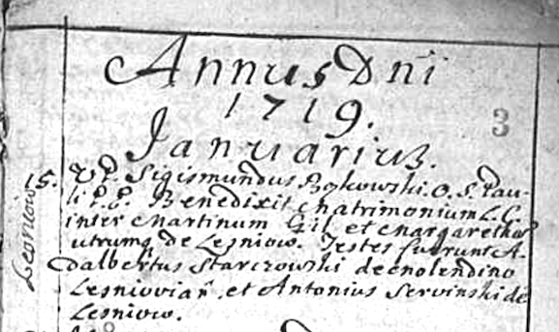

Maria Zmijewska wrote that “the wedding and the rituals associated with it were the most important event in the personal life of the population (...). It was accompanied by carefully cultivated centuries-old traditions.”[45] Among these traditions was the betrothal, which was not mentioned in the Tametsi decree.[46] Through intermediaries or matchmakers, after the courtship, which happened quickly, an engagement took place. In the Żarki area, these took place on Thursday late in the evening, where a matchmaker entering the home of the bride-to-be would call out: “Don’t you have a heifer to sell?”[47] At a smaller or larger celebration, a marriage contract was made between the family, which defined the personal and property relations of the future spouses and the amount of the dowry. Determining the amount of the dowry was considered “a relic of the pagan custom of marriage by purchase.”[48] At the time of betrothal, the exchange of wreaths took place as a mutual pledge of future marriage. In pre-Tridentine tradition, the act of betrothal was more important than the act of marriage itself. Thus, the act of marriage was a natural consequence of the betrothal, an agreement between two parties, and when it came to fruition, one would go to the rectory to announce the marriage.[49]

“According to the old custom, the young man and the girl should invite[50] witnesses and guests to the wedding.” The quote shows that the newlywed couple were the initiator of the social interaction. This information is important for the process of reconstructing the directed network.

**The Concept for Applying the Network Analysis Method**

First Stage: Definition of the Nodes and Relationships

In the marriage registers of the parish of Zarki, three types of nodes can be distinguished: clergy, brides and grooms, and witnesses, the so-called ordinary witnesses. The clergy is excluded ex officio because of its role, since the purpose of reconstructing the network is to study the relationships between the inhabitants of the parish of Żarki.[51] Two types of nodes remain: nurses and ordinary witnesses. Graphically, they are represented as circles (figure 2).

Figure 2. The main actors, the fiancés and the witness



Notation in circles signifies: **N**—fiancé/ fiancée (from the Latin *nupturient*, fiancé, bridegroom, betrothed);[52] **T** – witness (from the Latin *testis*—witness).[53] In addition, colors were introduced to better distinguish the border: **N**—blue and **T**—green (figure 2). Looking more closely at the **N** elements, a further division into two sets comes to mind: male and female (figure 3).

Figure 3. The main actors, the fiancé, the fiancée and the witness



Which, of course, changes the notation of the nodes, where **NM1** means: **N**–bridegroom, **M**–man (Latin: masculus); analogous to **NF1**: **N**–bride, **F**–woman (Latin: femina) in both cases the digit **1** symbolically represents the ordinal number. At the same time, the **T** node type has been expanded to include an ordinal number.

Establishing the marriage relationship between the nodes of the bridegroom and bride is as follows: nupturient **NM1** (male), is one party to the contract and **NF1** (female) is the other party to the contract (see figure 3). As they stand on the wedding dais, they express their mutual will to marry. This proceeds as follows: **NM1** expresses a message in the direction of **NF1** while simultaneously **NF1** expresses a message in the direction of **NM1**, soboth sides interact (figure 4).

Figure 4. The marital relationship

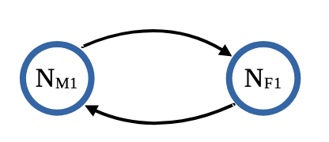

From the point of view of the social network, Dorothea Jansen explains the directed relationship as follows: if **A** is the son of **B** then **B** cannot simultaneously be the father of **A**. This is a directed relationship. If, on the other hand, we look at the relationship of kinship, this is an undirected relationship, for if **A** is related to **B** then **B** is related to **A**. All relationships based on common membership are undirected in nature.[54]

The betrothed are not yet at the stage of kinship, since they are just establishing a family unit. Dispensations by virtue of kinship between the nuptial couple appear in the marriage registers. But in forming this relationship, the question is not whether **NM1** is a relative of **NF1**, but whether **NM1** takes **NF1** as his wife and whether **NF1** takes **NM1** as her husband. By virtue of this, a mutual directed relationship is formed,[55] which the literature also calls “the reciprocity of ties.”[56]

In the graphs created by social network analysis, a two-way link will be represented as a double arrow (figure 5).

Figure 5. The marital relationship: a double arrow

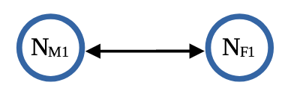

The resulting graph type is called a dyad in the literature[57]—the smallest construct in graph theory and social network structure (two points and the relationship(s) between them).

Notation for figure 5:

V = {N**M1**, N**F1**}, (2)

A = {(N**M1**, N**F1**), (N**F1**, N**M1**)}. (3)

Figure 6 below visualizes three possible relationships for establishing a witness relationship between **NM1** (the bridegroom) and **T1** (the customary witness); two relationships directed from **NM1** toward **T1** and from **T1** toward**NM1**, and one **NM1** undirected relationship toward **T1** and from **T1** toward**NM1**.

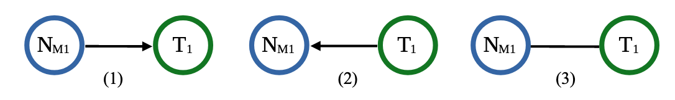Figure 6. Relationship between the bridegroom and witness or between the witness and bridegroom

From folk tradition, it is known that the bride and groom invited witnesses and guests to the wedding. Thus, we get a directed relationship: **NM1** and **NF1** ask **T1** tobe theirwitness (figure 7), where the nupturients will be the initial nodes (sender) and the witness(es) will be the end nodes (receiver) of the information flow.[58]

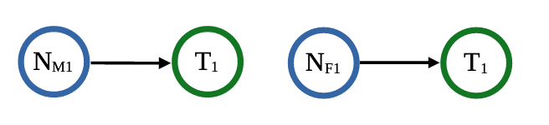Figure 7. The witness relationship between the prospective spouses and the witness—dyad

The combination of the three defined basic elements (**NM1**, **NF1**, **T1)** forms a triad (figure 8).

Notation for figure 8:

V = {NM1, NF1, T1}, (4)

A = {(N**M1**, N**F1**), (N**F1**, N**M1**), (NM1, T1), (NF1, T1)}. (5)

Figure 8. Relationship between prospective spouses and the witness—triad

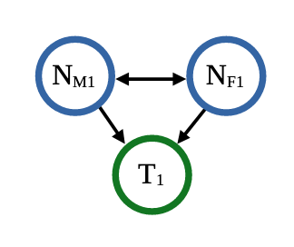

With that, the marital relationship is symmetrical, bilateral, mutual, and the witnessing relationship is unilateral, and asymmetrical. The resulting arrangement is transitive—all the components have been interconnected and have formed a triad.[59]

Second Stage: Creating Models and Scenarios

**Scenario Number 1—Diagram 1**

After defining the types of nodes, as well as the relationships in the 18th-century social network, a first diagram emerged based on the standard marriage certificate notation: a bridegroom and bride, assisted by two witnesses, stand on the wedding dais.

Diagram 1

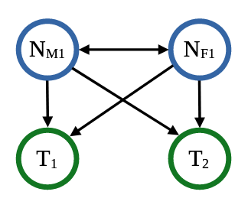

Notation:

V = {NM1, NF1, T1, T2} (6)

A = {(NM1, NF1), (NF1, NM1), (NM1, T1), (NF1, T1), (NM1, T2), (NF1, T2)} (7)

**Scenario number 2—Diagram 2**

Scenario: the groom, a bachelor (**NM1**), and the bride, a spinster (**NF1**), stand on the wedding dais, and two people (**T1**, **T2**) have been asked to be witnesses. Marital life ends after two years, due to the death of the husband. The new widow, after two months, once again stands on the wedding dais. In other words, the bride, a widow (**NF1**) is taking a new spouse, a bachelor (**NM2**). At the second wedding ceremony, the number of witnesses has increased from two to three (**T2**, **T3**, **T4**)—diagram 2.

Diagram 2

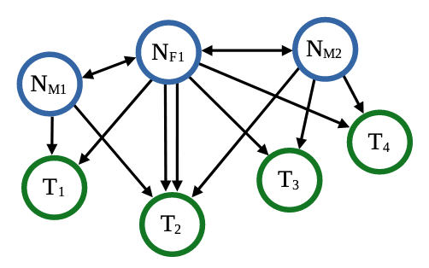

Notation:

V = {NM1, NF1, NM2, T1, T2, T3, T4} (8)

A = {(NM1, NF1), (NF1, NM1), (NM1, T1), (NF1, T1), (NM1, T2), (NF1, T2), (NF1, NM2), (NM2, NF1),  
 (NF1, T2), (NF1, T3), (NF1, T4), (NM2, T2), (NM2, T3), (NM2, T4)} (9)

The model created depicts two weddings at a certain interval. In the construct, attention is drawn to the witness **T2**, with as many as four arrows pointed at him or her— (s)he took part not only in the first wedding ceremony, but also in the second. Such an arrangement may signal possible kinship or affinity with the bride.

**Scenario Number 3—Diagram 3**

The next scenario: the groom, a bachelor (**NM1**), marries his bride, a spinster (**NF1**). The wedding ceremony is witnessed by two people (**T1**, **T2**). After two years, **NM1** is widowed, as his wife (**NF1**) dies giving birth to their second child. The groom, now a widower (**NM1**), enters into a new marriage with his bride, a spinster (**NF2**). Two people (**T3**,**T4**), who have not been witnesses before (in this small network), are asked to be witnesses. After some time, **NM1** dies. The widow (**NF2**), because of her young children, remarries. The bride/widow (**NF2**), and her groom, a bachelor (**NM2**), ask two new people to be witnesses (**T5**,**T6**)—diagram 3.

Notation:

V = {NM1, NF1, NM2, NF2, T1, T2, T3,T4, T5,T6} (10)

A = {(NM1, NF1), (NF1, NM1), (NM1, T1), (NF1, T1), (NM1, T2), (NF1, T2), (NF2, NM1), (NM1, NF2),

(NF2, T3), (NF2, T4), (NM1, T3), (NM1, T4), (NF2, NM2), (NM2, NF2), (NM2, T5), (NM2, T6),

(NF2, T5), (NF2, T6)} (11)

E = {{T1, T2}} (12)

The model reconstructs three marriages, with ceremonies attended by different witnesses. The novelty of this diagram is the introduction of information concerning the relationship between witnesses **T1** and **T2** i.e., they were already declared to be married. As a result, there was an affinity relationship between them, which is undirected. Directed and undirected connections in one graph are perfectly possible.[60]

Diagram 3

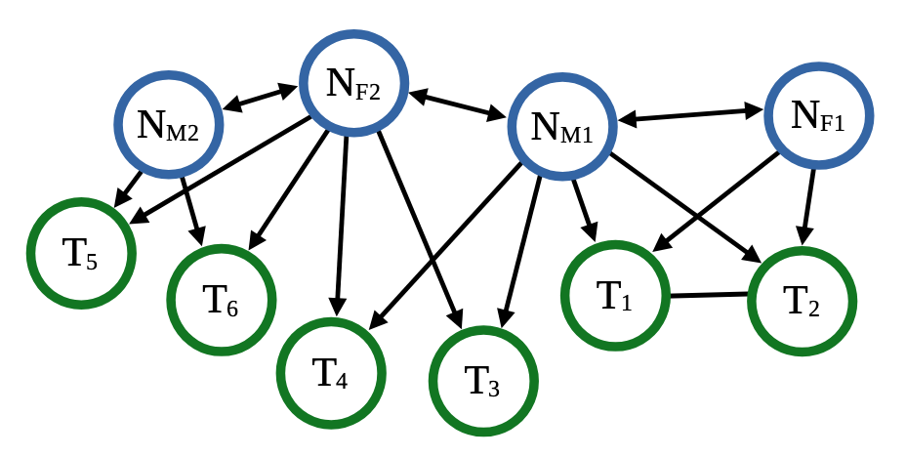

**Scenario Number 4—Diagram 4**

Another scenario: a bachelor (**NM1**) marries a spinster (**NF1**), witnessed by persons (**T1**, **T2**) who are related to each other. After two years, **NF1** dies. The groom, a widower (**NM1**), enters into a new marriage with a spinster (**NF2**). Two new people (**T3**,**T4**) are asked to be witnesses. In the same year, in the same network, witness **T4** is widowed and marries again. And he requests as witness **NM1**, who has already been assigned to node **NM1** in the graph. The question arises how best to graphically represent the above situation. How do we make node **NM2** out of node **T4** **,** and make a new node **T5** out of node **NM1** (diagram4)?

Diagram 4

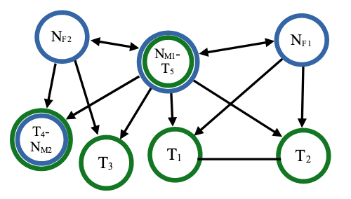

And this is where we move to the next stage of the concept.

Third Stage—Modifying the Concept

For understanding simple scenarios, the previous concept worked perfectly. It is not a problem if spouses remain in the network within their class and occasionally enter into new marriages. Similarly, the functioning of witnesses in the same network can be explained. This all changes when the same node plays more than one role in the same network. In the initial analysis of the source material from which nodes/actors were extracted, the attribution aspect prevailed. Looking for similar attributes among the participants of the events, on the basis of which they were categorised, the natural consequence was the extraction of three classes (**NM**, **NF**, **T**). However, this is too rigid for the reconstruction of the social network in time and space. The above analysis modifies the original assumptions of the concept. Instead of three categories of one and the same set, a large set of nodes appears without any further specifications (diagram 5).

Diagram 5

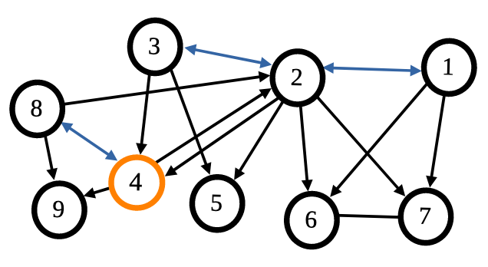

Marital relationships in diagram 5 have been colored blue to distinguish them from other relationships.

Current notation:

V = {1, 2, 3, 4, 5, 6, 7, 8, 9}, (13)

A = {(1,2), (2,1), (1,7), (1,6,), (2,7), (2,6), (2,3), (3,2), (2,5), (2,4), (3,5), (3,4), (4,8), (8,4), (4,9),

(4,2), (8,9), (8,2)}, (14)

E = {{6, 7}}. (15)

A simple analysis of node number four (colored orange) in diagram 5 in terms of relationships can be as follows:

* node four was asked to witness the wedding of a couple (2–3)—witness relationship,
* node four agreed to marry node number eight—marriage relationship,
* node eight agreed to marry node number four—marriage relationship,
* node four asked node number two and node number nine to participate in the wedding ceremony—witness relationship.

To summarize: the attributes[61] of an individual (whether one studies individuals, groups or institutions) are interesting and important, but the key to social network research is provided by the analysis of the relationships between them, in the network.[62] For as the above examples show, positions and roles change over time and space. For the research topic presented here, a relational approach to reconstructing the 18th century network is more appropriate than an attributional one.

Preparing the Database for Network Visualization Using the Gephi Program

So far in this article, graphs have been used as abstract models to discuss issues of simple network structures. In Social Network Analysis, different types of computer programs are used to visualize networks. This article uses the Gephi program.[63] To use it, it is necessary to convert the research material into two simple tables, one for nodes and the other for relationships. Microsoft Excel can be used to generate such tables.

The table of nodes (nodelist) should contain at least two columns: the first colum, ‘ID,’ is ordinal numbers (which are very important because they act as an identification key), and the second column, ‘label,’ can contain their terms. It is important that the data is not repeated, i.e., there is only one actor with the label Czyż in the whole network. If, on the other hand, there are more people with the surname Czyż in the source material, it is necessary to check, if possible, which people are involved. In this case, it will be helpful to enter an additional criterion in the table for distinguishing actors; for example, the date of baptism will be helpful.

Table 1. List of nodes

|  |  |  |  |  |
| --- | --- | --- | --- | --- |
| ID | Label | Gender | Date of baptism | Date of burial |
| 1 | Czyż | Female | 1718-03-12 |  |
| 2 | Baran | Male |  |  |
| 3 | Karoń | Female |  |  |
| 4 | Wapler | Male |  |  |
| 5 | Werner | Male |  |  |
| 6 | Fider | Male |  |  |
| 7 | Fider | Female |  | 1766-01-11 |
| 8 | Frezer | Female |  |  |
| 9 | Laykauf | Male |  |  |
| 10 | Serwin | Female |  |  |
| 11 | Legutek | Male |  |  |

Source: own work.

Table number 1 contains a pair of such criteria, such as surname or forename (label), gender, date of baptism or burial (viewed through the prism of 18th-century circumstances). What additional information the node table will contain is an individual decision for each researcher.

Table 2 gives examples of links/relationship (edgelist) parameters between nodes that the marriage records of an 18th century parish can provide. Two columns are required: source and target. In the example of table 2, the first column labeled ID is created by Gephi (so that each row of the table has a unique assignment) and does not need to be included in the database. For the following example, it was created manually. According to table 2, the relationships connecting the nodes in diagram 6 are numbered.

Diagram 6

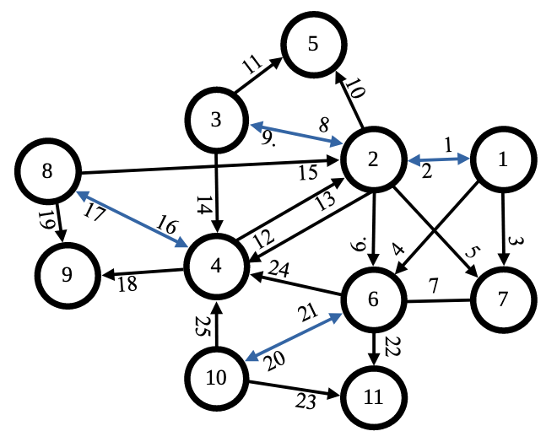

Analyzing relationship number twenty-two (table 2 and diagram 6), which connects the nodes numbered six and eleven, we can say that the relationship is directed and belongs to the witness category. Adding the information from the list of relationships (table 2), we learn that actor number six was a widower and there was no kinship between the nodes.

Another example of analysis for node six in terms of relationships (table 2 and diagram 6): in 1765 he was a witness with his wife (number seven in table 1) at the wedding of a spinster from the house of Czyż and a bachelor named Baran—relationship number seven between nodes six and seven is a kind of affinity relationship. In 1767, as a widower, he remarried (an affinity relationship—number twenty in diagram 6) without specifying the marital status of his future spouse. He asked two people to be his witnesses. Witness number four (witness relationship number twenty-four in diagram 6) was the mayor of a small town at the time (suggestion: was he asked to be a witness for the prestige of the groom?) The wedding was blessed by priest Stanisław Tagibor.

Table 2. List of connections

|  |  |  |  |  |  |  |  |  |  |  |  |  |  |  |  |  |
| --- | --- | --- | --- | --- | --- | --- | --- | --- | --- | --- | --- | --- | --- | --- | --- | --- |
| **ID** | **Source** | **Target** | **Edge**  **type** | **Rel. type** | **Mar.st.: so.** | **Mar.st: target** | **Fam. rel.** | **Dis.** | **Occupation: so.** | **Occupation: target** | **Date of marriage** | **Parish priest** | **Parish: so.** | **Parish: target** | **Place: so.** | **Place: target** |
| 1 | 1 – Czyż | 2 – Baran | a | mar. | s. | b. | kin. | ja |  | miller | 1765-01-03 | Wyporski Augustus | Żarki | Niegowa | Jaworznik | Łutowiec |
| 2 | 2 – Baran | 1 – Czyż | a | mar. | b. | s | kin. | ja | miller |  | 1765-01-03 | Wyporski Augustus | Niegowa | Żarki | Łutowiec | Jaworznik |
| 3 | 1 – Czyż | 3 – Karoń | a | wit. | s. | w. | ab. |  |  |  | 1765-01-03 | Wyporski Augustus | Żarki | Żarki | Jaworznik | Żarki |
| 4 | 1 – Czyż | 6 – Fider | a | wit. | s. | h. | ab. |  |  |  | 1765-01-03 | Wyporski Augustus | Żarki | Żarki | Jaworznik | Żarki |
| 5 | 2 – Baran | 7 – Fider | a | wit. | b. | w. | ab. |  |  |  | 1765-01-03 | Wyporski Augustus | Żarki | Żarki | Łutowiec | Żarki |
| 6 | 2 – Baran | 6 – Fider | e | wit. | b. | h. | ab. |  |  |  | 1765-01-03 | Wyporski Augustus | Żarki | Żarki | Łutowiec | Żarki |
| 7 | 6 – Fider | 7 – Fider | a | aff. | w. | h. | aff. |  |  |  | 1765-01-03 | Wyporski Augustus | Żarki | Żarki | Żarki | Żarki |
| 8 | 3 – Karoń | 2 – Baran | a | mar. | s. | wd. | ab. |  |  |  | 1767-12-15 | Tagibor Stanisław | Żarki | Żarki | Jaroszów | Jaworznik |
| 9 | 2 – Baran | 3 – Karoń | a | mar. | wd. | s. | ab. |  | miller |  | 1767-12-15 | Tagibor Stanisław | Żarki | Żarki | Jaworznik | Jaroszów |
| 10 | 2 – Baran | 5 – Werner | a | wit. | wd. | br. | ab. |  | miller | miller | 1767-12-15 | Tagibor Stanisław | Żarki | Żarki | Jaworznik | Żarki |
| 11 | 3 – Karoń | 5 – Werner | a | wit. | s. | br. | ab. |  |  | miller | 1767-12-15 | Tagibor Stanisław | Żarki | Żarki | Jaroszów | Żarki |
| 12 | 2 – Baran | 4 – Wapler | a | wit. | wd. | br. | ab. |  |  | mayor | 1767-12-15 | Tagibor Stanisław | Żarki | Żarki | Jaworznik | Żarki |
| 13 | 4 – Wapler | 2 – Baran | a | wit. | wd. | w. | ab. |  | mayor |  | 1767-12-28 | Tagibor Stanisław | Żarki | Żarki | Żarki | Jaworznik |
| 14 | 3 – Karoń | 4 – Wapler | a | wit. | s. | br. | ab. |  |  | mayor | 1767-12-15 | Tagibor Stanisław | Żarki | Żarki | Jaroszów | Żarki |
| 15 | 8 – Frezer | 2 – Baran | a | wit. | ww. | w. | ab. |  |  |  | 1767-12-28 | Tagibor Stanisław | Żarki | Żarki | Żarki | Żarki |
| 16 | 8 – Frezer | 4 – Wapler | a | mar. | ww | wd. | kin. |  |  | mayor | 1767-12-28 | Tagibor Stanisław | Żarki | Żarki | Żarki | Żarki |
| 17 | 4 – Wapler | 8 – Frezer | a | mar. | wd. | w. | kin. |  | mayor |  | 1767-12-28 | Tagibor Stanisław | Żarki | Żarki | Żarki | Żarki |
| 18 | 4 – Wapler | 9 – Laykauf | a | wit. | wd. | ab. | ab. |  | mayor |  | 1767-12-28 | Tagibor Stanisław | Żarki | Żarki | Żarki | Żarki |
| 19 | 8 – Frezer | 9 – Laykauf | a | wit. | ww | ab. | ab. |  |  |  | 1767-12-28 | Tagibor Stanisław | Żarki | Żarki | Żarki | Żarki |
| 20 | 6 – Fider | 10 – Serwin | a | mar. | wd. | ab. | ab. |  |  |  | 1767-12-30 | Tagibor Stanisław | Żarki | Żarki | Żarki | Żarki |
| 21 | 10 – Serwin | 6 – Fider | a | mar. | ab. | wd. | ab. |  |  |  | 1767-12-30 | Tagibor Stanisław | Żarki | Żarki | Żarki | Żarki |
| 22 | 6 – Fider | 11 – Legutek | a | wit. | wd. | ab. | ab. |  |  |  | 1767-12-30 | Tagibor Stanisław | Żarki | Żarki | Żarki | Żarki |
| 23 | 10 – Serwin | 11 – Legutek | a | wit. | ab. | ab. | ab. |  |  |  | 1767-12-30 | Tagibor Stanisław | Żarki | Żarki | Żarki | Żarki |
| 24 | 6 – Fider | 4 – Wapler | a | wit. | wd. | w. | ab. |  |  | mayor | 1767-12-30 | Tagibor Stanisław | Żarki | Żarki | Żarki | Żarki |
| 25 | 10 – Serwin | 4 – Wapler | a | wit. | w. | wd. | ab. |  |  | mayor | 1767-12-30 | Tagibor Stanisław | Żarki | Żarki | Żarki | Żarki |

Source: own work.

Explanation of abbreviations: **Table headings**: rel. type – type of relationship; mar. st.: so.–marital status: source; mar. st.: tar. – marital status: target; fam. rel. – family relationship; dis. – dispensation; occ.: so. – occupation: source; **information in table columns**: a – directed relationship; e – undirected relationship; mar. – married; wit. – witness; aff. – affinity; s. – spinster; b – bachelor; w.– wife; h. – husband; wd. – widower; w. – widow; ab. – information absent; kin. – kinship.

An Example of a Directed Network Based on the Żarki Parish Marriage Registers

Figure 9 shows the so-called raw graph. The Gephi program randomly generated it based on the input information (nodelist, edgelist) using the source material from the Marriage Register of 1718–1720.[64]

Figure 9. The social and community network of Żarki Parish residents (1718–1720)

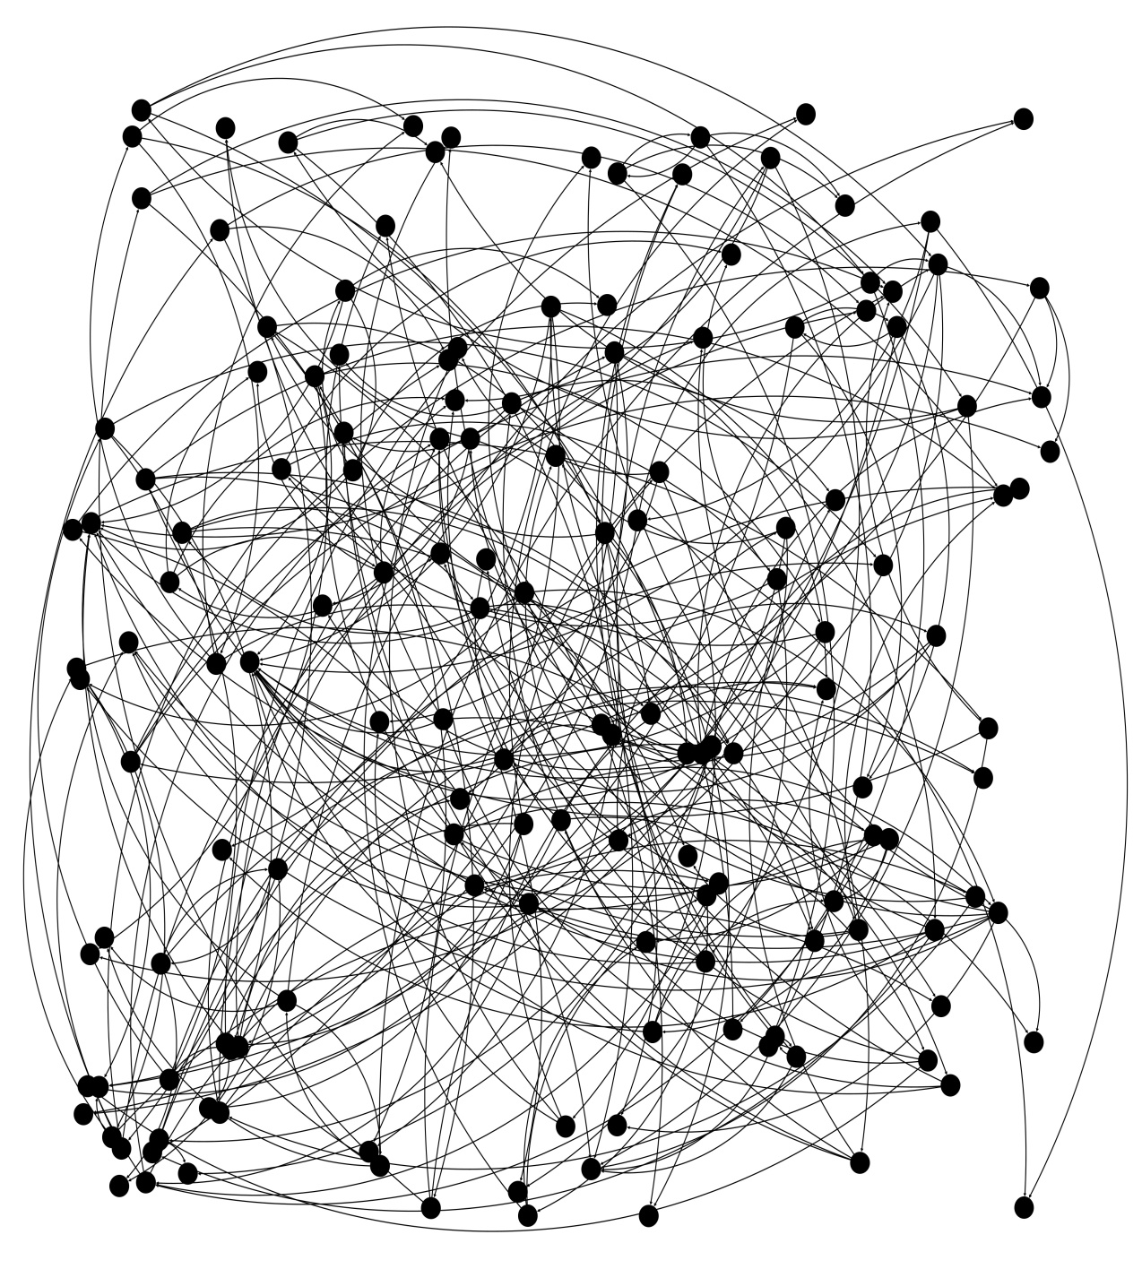

In this rather short period of time, the Żarki community recorded 154 actors (nodes)[65] and 266 directed relationships, of which 84 were marital relationships. The number of marriages was 42. The shape of the network is more like a cluster of lines and points. For better visualization, the original network was further specified using the Fruchterman Reingold algorithm. This algorithm works on the principle of a spiral. Each node is subjected to forces of attraction and repulsion[66] to find its optimal position in the structure. In addition, marriage relationships are highlighted in red and node terms are added (modernized font)—figure 10.

Figure 10. The social network of Żarki Parish residents (1718–1720).

Fruchterman Reingold algorithm

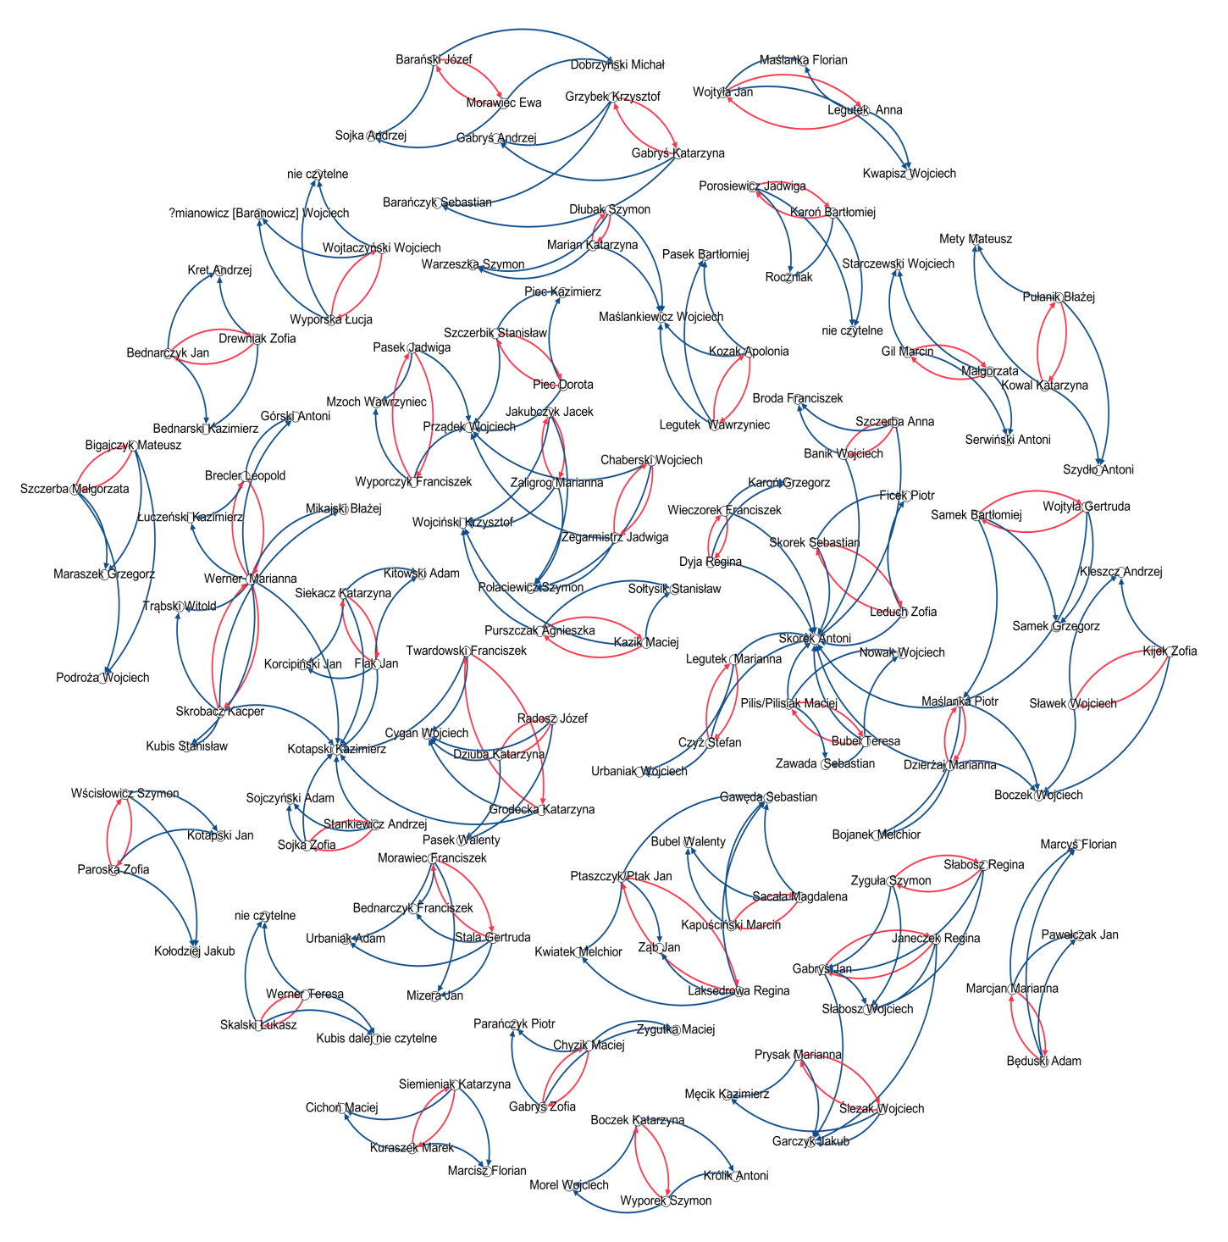

Figure 11. The social and community network of Żarki Parish residents (1718–1720).

Division according to modularity class

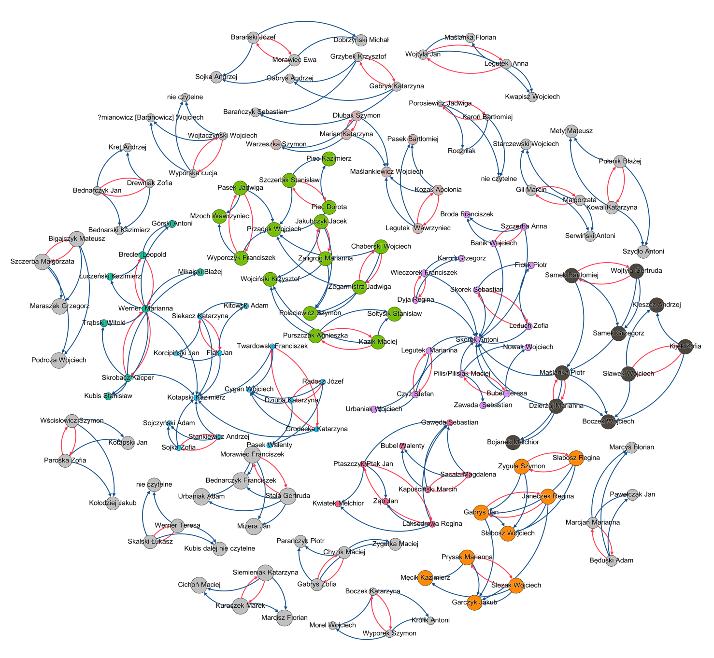The generated network can be subjected to a variety of analyses provided by the Social Network Analysis method and included in the Gephi program. It is beyond the scope of this article to describe all the analytical or statistical tools of SNA. The following example is only an approximation of this method. Figure 11 shows smaller components (in green, orange, or black) isolated from the entire network, called clusters, modules, or cliques, whose structures can be isolated and subjected to further study of network connections. In addition, in the following network it is possible to distinguish individuals (Skorek Antoni or Kotapski Kazimierz), which have more directed relationships concentrated on themselves. These tendencies can be analyzed in terms of centrality coefficient (degree, agency or proximity).

**Conclusions**

The results of the article are a series of models that visually represent the various stages of the idea of applying the Social Network Analysis method to historical demography. The basic concepts of graph, network, social network, nodes, directed and undirected relationships are outlined. From the combinations of the two smallest elements (nodes and relationships), the resulting structures made it possible to create the models described, abstractly but nevertheless on the basis of information from parish sources. The framework of the social-relational network consisting of the engaged couple and their witnesses was defined. Due to the fact that the clergy occupied the position of ex officio witnesses, they were indirectly excluded from the set of nodes, but information about them was included in the database of individual relationships. The diagrams created were intended to highlight the problem of the attributive reasoning of individuals and the role of relationships between them. In the center of interest of the social network are the connections/relationships between individuals, and only from this perspective the role of individuals in the network is studied, analyzed and described. Two types of relationships are distinguished: marital, which occurs between two prospective spouses, symmetrical with a directed, reciprocal nature, and witness, which occurs between prospective spouses and ordinary witnesses, asymmetrical with a directed nature. To visualize the network using computer programs, examples of tables were given to structure the database for their purposes. The final result was the social-social network of the parish of Żarki. Admittedly, the example only covers three years, but it is already possible to identify certain trends, such as the formation of cliques or the accumulation of relationships on a single node.

The limitations of the SNA method may be due to the research material, in this case marriage records. The social network thus constructed is only a rudimentary substitute for the community that actually existed in the 18th century. It is not clear from the marriage relationships defined above to what extent, for example, the betrothed were forced into this union. It is difficult to determine, and even more difficult to measure, whether these relationships were based on affection. It is also difficult to define kinship relationships among witnesses or between witnesses and prospective spouses based on surname coincidences. Another limitation may come from the method of compiling the database, as it involves a lot of work; painstakingly going through the registers, then collating and structuring the data for the SNA method.

Despite the limitations of the method, the cognitive benefits gained from it of small-town social structure can contribute to a better understanding of the dynamics of contemporary society.

**APPENDIX**

Appendix 1. Comparison of directed graph vs. undirected graph1

|  |  |  |
| --- | --- | --- |
|  | Directed graph | Undirected graph |
| Formula | Gd= (V, A)3  Directed Graph = (Vertex, Arc) | G = (V, E)2  Graph = (Vertex4, Edge) |
| Meaning of abbreviations | Gd– directed graph  V – vertex  A – arc | G – graph  V – vertex  E – edge |
| Definition | A directed graph consists of two finite sets: vertices (V) and arcs (A).  The set of vertices is not empty, while the set of arcs can be empty.  Where a pair of vertices has been assigned to each arc (A). | An undirected graph consists of two finite sets: vertices (V) and edges (E).  The set of vertices is not empty, while the set of edges can be empty.  Where each edge (E) has been assigned a pair of vertices (although not always different). |
| Other names for V | node, point | node, point |
| Other names for A/E | A: directed edge, directed line, arc, arrow | E: undirected edge, line |
| Notation form for V: example | V = {a,b,c} | V = {a,b,c} |
| Notation form for A/E: example | A = {a1, a2, a3}  a1 = {(b,a)}5 | E = {e1, e2, e3}  e1 = {a,b}4 |
| Fundamental differences between A and E | A: The connection works only in the direction of the directed edge, that is, from **b** to **a,** not from **a** to **b**. | E: The direction in the graph can be from **a** to **b** and from **b** to **a**. |
| Start/end node | a1 = (b,a)  point b is the start point of edge a1; point a is the end point of edge  a1. | e1 = (a,b)  points a and b are the end points of the line/relationship e1. |
| Examples |  |  |

Source: own work based on John Clark and Derek Allan Holton, *Graphentheorie Grundlagen und Anwendungen*, Spektrum 1994; Peter Trittmann, *Graphentheorie: eine anwendungsorientierte Einführung*, Hanser Verlag, 2011; Robin J. Wilson, *Introduction to Graph Theory*, Longman, 1996.

“The language of graph theory is not standard—all authors have their own terminology (…). Any such definition is perfectly valid, provided that it is used consistently” (Wilson, *Introduction*, 9). For this reason, other forms of notation are given below.

1. As per Jacek M. Wojciechowski and Krzysztof Pieńkosz, *Grafy i sieci*, (Wydawnictwo Naukowe PWN, 2013), 1. An undirected graph is referred to as a non-oriented graph, while a directed graph is referred to as an oriented graph.

2. Another form of notation: G = (V(G)), E(G)) as per Clark and Holton, *Graphentheorie*, 2.

3. Another form of notation: G = (V, E) as per Trittmann, *Graphentheorie*, 127, orD = (V(D)), A(D)) as perWilson, *Introduction to Graph Theory*, 100.

4. Or *nodes*: Wilson*, Introduction to Graph Theory*, 8.

5. Another form of notation: e1 = {a,b} as per Trittmann, *Graphentheorie*, 13; or e1 = ab as per Wilson, *Introduction*, 8.

6. Another form of notation: a1 = ba as per Wilson, *Introduction*, 101.

7. Undirected graph G = (V, E) can be obtained from the directed graph Gd = (V, A), when one moves gradually from A to A’ ⊃ A by adding a1 = (b,a) ∈ A ⊂ A’, a1 ’= (a,b) and identifying a1 and a1’ using e1 = (a,b) ∈ E. Therefore, undirected graphs are general graphs. Clark and Holton, *Graphentheorie*, 252–53; Wilson, *Introduction*, 100–102.

**Bibliography**

Abraham, Władysław. *Forma zawarcia zaręczyn i małżeństwa w najnowszem ustawodawstwie kościelnem*. Gubrynowicz i Syn, 1913.

Bardach, Juliusz, Bogusław Leśnodorski, and Michał Pietrzak. *Historia państwa i prawa polskiego*. 5th ed. PWN, 1987.

Buchnea, Emily, and Ziad Elsahn. “Historical Social Network Analysis: Advancing New Directions for International Business Research.” *International Business Review* 31, no. 5 (2022): 101990. <https://doi.org/10.1016/j.ibusrev.2022.101990>.

Chojecki, Dariusz K. “Działalność naukowa profesora Edwarda Włodarczyka w świetle publikacji autorskich (1973–2020). Kontekst ilościowy.” *Zapiski Historyczne* 87, no. 1 (2022): 107–32. <https://doi.org/10.15762/ZH.2022.05>.

Chojecki, Dariusz K., and Radosław Gaziński. “Le réseau de sociabilité des huguenots dans le Szczecin prussien au début du XVIII siècle à la lumière des données sur les baptêmes.” *Annales de Démographie Historique* 147, no. 2 (2024) [forthcoming].

Chwalba, Andrzej. *Obyczaje w Polsce. Od średniowiecza do czasów współczesnych*. Wydawnictwo Naukowe PWN, 2015.

Clark, John, and Derek Allan Holton. *Graphentheorie: Grundlagen und Anwendungen*. Spektrum, 1994.

Dąbkowski, Przemysław Roman. *Zarys prawa polskiego prywatnego: podręcznik do nauki uniwersyteckiej*. 2nd ed . K. S. Jakubowski, 1921.

Deiksler, Roman. “Social Network Analysis in the Study of the Works of Josephus. The Case Study of Galilee during the First Jewish Revolt.” *Folia Praehistorica Posnaniensia* 24 (2019): 35–46. <https://doi.org/10.14746/fpp.2019.24.02>.

Dörpinghaus, Barbara, and Hans-Georg Wünch. “Relationships and Forms in the Social Network of the Jacob Narrative: A Narratological Perspective.” *Old Testament Essays* 36, no. 2 (2023): 347–67. <https://doi.org/10.17159/23123621/2023/v36n2a4>.

Dul, Aleksandra. “Życie towarzyskie dziewiętnastowiecznej wiejskiej parafii. Analiza sieci społecznych.” *Przeszłość Demograficzna Polski – Poland’s Demographic Past* 39 (2017): 167–208. <https://doi.org/10.18276/pdp.2017.39-08>.

Fedorowski, Michał. *Lud okolic Żarek, Siewierza i Pilicy Jego zwyczaje, sposób życia, obrzędy, podania, gusła, zabobony, pieśni, zabawy, przysłowia, zagadki i właściwości mowy*. Vol. 1. Księgarnia M. Arcta, 1888.

Ferguson, Niall. *Rynek i ratusz. O ukrytej sieci powiązań, która rządzi światem*. Translated by Wojciech Tyszka. 2nd ed. Wydawnictwo Literackie, 2024.

Fuhse, Jan Arendt. *Soziale Netzwerke. Konzepte und Forschungsmethoden*. UVK Verlag, 2016.

Gieysztorowa, Irena. “Niebezpieczeństwa metodyczne polskich badań metrykalnych XVII–XVIII wieku.” *Kwartalnik Historii Kultury Materialnej* 19, no. 4 (1971): 557–603.

Gieysztorowa, Irena. *Wstęp do demografii staropolskiej*. PWN, 1976.

Gregorowicz, Dorota. “Mieszczańska kariera w szlacheckiej Rzeczypospolitej? Francesco De Gratta i jego *social network*.” *Zapiski Historyczne* 87, no. 2: 133–49. <https://doi.org/10.15762/ZH.2022.17>.

Holzer, Boris, and Christian Stegbauer, eds. *Schlüsselwerke der Netzwerkforschung*. Springer VS, 2019.

Internet Database: Family Search. https://www.familysearch.org/.

Jansen, Dorothea. *Einführung in die Netzwerkanalyse: Grundlagen, Methoden, Forschungsbeispiele*. Verlag für Sozialwissenschaften, 2006.

Knoke, David, and Song Yang. *Social Network Analysis*. Sage Publications, 2020.

Korybut-Marciniak, Maria. “Potencjał analizy sieci społecznych w badaniach egodokumentów.” *Rocznik Antropologii Historii* 13 (2020): 257–73. <https://doi.org/10.25945/RAH.2020.13.011>.

Krischke, André, and Helge Röpcke. *Graphen und Netzwerktheorie: Grundlagen, Methoden, Anwendungen*. 2nd ed. Hanser Verlag, 2024.

Kuklo, Cezary. *Demografia Rzeczypospolitej przedrozbiorowej*. DiG, 2009.

Kuklo, Cezary. “Badania nad historią kobiet w Polsce XVI–XVIII wieku w latach 2011–2020. Niezmienna atrakcyjność, ale czy nowe pytania?” *Acta Universitatis Lodziensis. Folia Historica* 107 (2020): 13–57. <https://doi.org/10.18778/0208-6050.107.02>.

Kumor, Bolesław. “Metryki parafialne w archiwach diecezjalnych.” *Kwartalnik Historii Kultury Materialnej* 14, no. 1 (1966): 65–75.

Laue, Reinhard. *Elemente der Graphentheorie und ihre Anwendung in den biologischen Wissenschaften*. Akademische Verlagsgesellschaft Geest & Portig K.-G., 1970.

Lischka, Marion. *Liebe als Ritual: Eheanbahnung und Brautwerbung in der frühneuzeitlichen Grafschaft Lippe*. Schöningh, 2006.

Minakowski, Marek Jerzy. “Social Network around Kurier Warszawski Based on its Obituaries of the Years 1821–1861.” *Przeszłość Demograficzna Polski – Poland’s Demographic Past* 39 (2017): 209–51. <https://doi.org/10.18276/pdp.2017.39-09>.

Minakowski, Marek Jerzy. “Family Network of Emerging Jewish Intelligentsia (Cracow 1850–1918).” *Journal of Historical Network Research* 2 (2018): 53–75.

Minakowski, Marek Jerzy. “House of Networks: The Polish-Lithuanian Senate (1569–1795) as Parliamentary Representation of the National Social Network (of Women?).” *Przeszłość Demograficzna Polski – Poland’s Demographic Past* 41 (2019): 33–56. <https://doi.org/10.18276/pdp.2019.41-02>.

Neuman, Mark, E. J. *Networks*. 2nd ed. Oxford University Press, 2018.

Pfeffer, Jürgen. “Visualisierung sozialer Netzwerke.” In *Netzwerkanalyse und Netzwerktheorie*. *Ein neues Paradigma in den Sozialwissenschaften*, edited by Christian Stegbauer. VS Verlag für Sozialwissenschaften, 2010. <https://doi.org/10.1007/978-3-531-92029-0_17>.

Pelczar, Józef. *Prawo małżeński katolickie u uwzględnieniem prawa cywilnego obowiązującego w Austryi. w Prusach i w Królestwie Polskiem*. 2nd ed. Drukarnia Uniwersytetu Jagiellońskiego, 1885.

Pister, Alexis, Nicole Dufournaud, Pascal Cristofoli, Christophe Prieur, and Jean-Daniel Fekete. “From Historical Documents to Social Network Visualization: Potential Pitfalls and Network Modeling.” VIS4DH 2022—7th *Workshop on Visualization for the Digital Humanities*. Oklahoma, 2022. <https://inria.hal.science/hal-03784532>.

Sierocki, Radosław. “Analiza sieci społecznych jako metoda badawcza w socjologii.” *Rocznik Antropologii Historii* 13 (2020): 223–55. <https://doi.org/10.25945/RAH2020.13.009>.

Sondel, Janusz. *Słownik Łacińsko-Polski dla prawników i historyków*. Universitas, 2009.

Stachyra, Wojciech. “Użyteczność badawcza struktur sieciowych w nauce o stosunkach międzynarodowych.” *Athenaeum Polskie Studia Politologiczne* 70, no. 2 (2021): 159–74.

Stein, Evina, and Gustavo Fernández Riva. *Networks of Manuscripts, Networks of Texts*. Special issue of *Journal of Historical Network Research* 9, no. 1 (2023).

Szpak, Jacek. *Dzieje Żarek – Leśniowa – Przewodziszowic: do 1870 roku*. Wydawnictwo Cum Laude, 2023.

Trittmann, Peter. *Graphentheorie: eine anwendungsorientierte Einführung; mit 113 Bildern, zahlreichen Beispielen und 80.* Hanser Verlag, 2011.

Tunia, Anna. “Kształtowanie się kanonicznej formy zawarcia małżeństwa.” *Roczniki Nauk Prawnych* 18, no. 1 (2008): 129–59.

Ufniarski, Stanisław. *Parafia w Żarkach* (n.d.). Bound copy held by the public library in Żarki, Sygn. 85.

Wetherell, Charles. “Historical Social Network Analysis.” *International Review of Social History* 43, no. S6 (1998): 125–44. <https://doi.org/10.1017/S0020859000115123>.

Wilson, Robin J. *Introduction to Graph Theory*. 4th ed. Prentice Hall, 2009.

Wojciechowski, Jacek M. and Krzysztof Pieńkosz. *Grafy i sieci*. Wydawnictwo Naukowe PWN, 2013.

Yang, Song, Franziska B. Keller, and Lu Zheng. *Social Network Analysis: Methods and Examples*. Sage Publications, 2017.

Związek, Jan. “Inwentarz łacińskich ksiąg metrykalnych Archiwum Diecezjalnego w Częstochowie.” *Archiwa, Biblioteki i Muzea Kościelne* 37 (1978): 175–220. <https://doi.org/10.31743/abmk.7111>.

Żmijewska, Małgorzata. “Ludność parafii tyskiej od 1749 roku do połowy XIX wieku w świetle ksiąg metrykalnych: studium demograficzno-społeczne.” PhD diss., Uniwersytet Śląski, Wydział Nauk Społecznych, 2008.

**Application of the Social Network Analysis Method to the Reconstruction of a Social and Kinship Network Based on the Marriage Registers of the 18th Century Parish of Żarki**

**Summary**

The article outlines the practical applicability of the SNA method for reconstructing the social network of a small town community in the 18th century, based on the marriage registers of the parish of Żarki. After reviewing the main concepts of social network analysis (nodes, directed and undirected relationships), they were further defined on graphical models. A step-by-step discussion of the concept using the SNA method to reconstruct social structures is intended to make the problem of attributionality of nodes and relationships between them in the network more apparent. As a result, the initial concept of implementing network reconstruction from the perspective of nodes/actors is changed in favor of relationships. The Gephi program was used to visualize the network. The final result is an example of a directed network created using the marriage registers of the Żarki parish from 1718–1720.

The article is a practical presentation of the application of the SNA method using a demographic source.

**Keywords:** Żarki parish, 18th century, SNA, social network analysis, social structure, social network, nodes, relationships, directed node, undirected node, reciprocal node, marital relationship, witness relationship, kinship/affinity relationship

**Cite this article (bibliography entry)**

Köster, Elżbieta. “Application of the Social Network Analysis Method to the Reconstruction of a Social and Kinship Network Based on the Marriage Registers of the 18th Century Parish of Żarki.” *Przeszłość Demograficzna Polski – Poland’s Demographic Past* 46 (2024): xx–xx. https://doi.org/10.18276/pdp.2024.46-06.

1. Niall Ferguson, *Rynek i ratusz. O ukrytej sieci powiązań, która rządzi światem* (The Square and the Tower: Networks and Power, from the Freemasons to Facebook) trans. Wojciech Tyszka, 2nd ed. (Wydawnictwo Literackie, 2024), 37.
2. Ferguson, *Rynek*, 38.
3. Irena Gieysztorowa, *Wstęp do demografii staropolskiej* (PWN, 1976); Irena Gieysztorowa, “Niebezpieczeństwa metodyczne polskich badań metrykalnych XVII–XVIII wieku,” *Kwartalnik Historii Kultury Materialnej* 19, no. 4 (1971): 557–603.
4. Various academic disciplines use the graph as an auxiliary element to better represent the relationships under study.
5. The parish of Żarki is located in the Kraków-Częstochowa Jura in the Silesian voivodeship. The oldest monograph was written by Stanisław Ufniarski, *Dzieje Parafii Żareckiej* (n.d.), Jasna Góra, with the latest by Jacek Szpak, *Dzieje Żarek – Leśniowa – Przewodziszowic: do 1870 roku* (Wydawnictwo Cum Laude, 2023).
6. The oldest parish registers are the *Liber Baptizatorum* of 1696, the *Liber Mortuorum* of 1718 and the *Liber Copulatorum* of 1718. They are kept in the Archdiocesan Archive in Częstochowa. The *Family Search* database is used for research. All three series of books are relatively complete. It was discovered that the *Liber Mortuorum* 1718–1757 series has no records for the year 1723.
7. Gieysztorowa, “Niebezpieczeństwa metodyczne,” 588; Gieysztorowa, *Wstęp*, 251–252.
8. Jan Związek, “Inwentarz łacińskich ksiąg metrykalnych Archiwum Diecezjalnego w Częstochowie,” *Archiwa, Biblioteki i Muzea Kościelne* 37 (1978): 175–220.
9. This age is calculated based on the baptismal records.
10. In addition, the following can be used: UCINET, R, SIENA, Pnet, Pajek or NodeXL. This article focuses on the theoretical possibility of developing a social structure without discussing Gephi software in detail.
11. Boris Holzer and Christian Stegbauer, eds, *Schlüsselwerke der Netzwerkforschung* (Springer VS, 2019), 507–14; Jan Ahrendt Fuhse, *Soziale Netzwerke. Konzepte und Forschungsmethoden* (UVK Verlag, 2016), 30–33; Dorothea Jansen, *Einführung in die Netzwerkanalyse: Grundlagen, Methoden, Forschungsbeispiele* (Verlag für Sozialwissenschaften, 2006), 37.
12. Holzer and Stegbauer, *Schlüsselwerke*, 425–28; Fuhse, *Soziale Netzwerke*, 35–36, Jansen, *Einführung*, 40.
13. Fuhse, *Soziale Netzwerke*, 48; Holzer and Stegbauer, *Schlüsselwerke*, 481–84; Jansen, *Einführung*, 43.
14. Holzer and Stegbauer, *Schlüsselwerke*, 31–34; Fuhse, *Soziale Netzwerke*, 50.
15. Jansen, *Einführung*, 40.
16. Alexis Pister et al., “From Historical Documents To Social Network Visualization: Potential Pitfalls and Network Modeling,” in *VIS4DH 2022: 7th Workshop on Visualization for the Digital Humanities* (Oklahoma, 2022), https://inria.hal.science/hal-03784532; Charles Wetherell, “Historical Social Network Analysis,” *International Review of Social History* 43, no. S6 (1998): 125–44, https://doi.org/10.1017/S0020859000115123; Emily Buchnea and Ziad Elsahn, “Historical Social Network Analysis: Advancing New Directions,” *International Business Review* 31, no. 5 (2022): 101990, https://doi.org/10.1016/j.ibusrev.2022.101990; Barbara Dörpinghaus and Hans-Georg Wünch, “Relationships and Forms in the Social Network of the Jacob Narrative: A Narratological Perspective,” *Old Testament Essays* 36, no. 2 (2023): 347–67, https://doi.org/10.17159/23123621/2023/v36n2a4; Roman Deiksler, “Social Network Analysis in the Study of the Works of Josephus. The Case Study of Galilee during the First Jewish Revolt,” *Folia Praehistorica Posnaniensia* 24 (2019): 35–46, https://doi.org/10.14746/fpp.2019.24.02; Maria Korybut-Marciniak, “Potencjał analizy sieci społecznych w badaniach egodokumentów,” *Rocznik Antropologii Historii* 13 (2020): 257–73, https://doi.org/10.25945/RAH.2020.13.011; Wojciech Stachyra, “Użyteczność badawcza struktur sieciowych w nauce o stosunkach międzynarodowych,” *Athenaeum Polskie Studia Politologiczne* 70, no. 2 (2021): 159–74, https://doi.org/10.15804/athena.2021.70.10; Evina Stein and Gustavo Fernández Riva, *Networks of Manuscripts, Networks of Texts*, special issue of *Journal of Historical Network Research* 9, no. 1 (2023), https://doi.org/10.25517/JHNR.V9I.
17. Cezary Kuklo, “Badania nad historią kobiet w Polsce XVI–XVIII wieku w latach 2011–2020. Niezmienna atrakcyjność, ale czy nowe pytania?,” *Acta Universitatis Lodziensis. Folia Historica* 107 (2020): 14, https://doi.org/10.18778/0208-6050.107.02.
18. Marek Jerzy Minakowski, “Social Networks Around *Kurier Warszawski* Based on its Obituaries of the Years 1821–1861,” *Przeszłość Demograficzna Polski – Poland’s Demographic Past* 39 (2017): 209–51, https://doi.org/10.18276/pdp.2017.39-09; Marek Jerzy Minakowski, “House of Networks: The Polish-Lithuanian Senate (1569–1795) as Parliamentary Representation of the National Social Network (of Women?),” *Przeszłość Demograficzna Polski – Poland’s Demographic Past* 41 (2019): 33–56, https://doi.org/10.18276/pdp.2019.41-02; Marek Jerzy Minakowski, “Family Network of Emerging Jewish Intelligentsia (Cracow 1850–1918),” *Journal of Historical Network Research* 2 (2018): 53–75.
19. Dorota Gregorowicz, “Mieszczańska kariera w szlacheckiej Rzeczypospolitej? Francesco De Gratta i jego social network,” *Zapiski Historyczne* 87, no. 2 (2022): 133–49, https://doi.org/10.15762/ZH.2022.17.
20. Dariusz K. Chojecki, “Działalność naukowa profesora Edwarda Włodarczyka w świetle publikacji autorskich (1973–2020). Kontekst ilościowy,” *Zapiski Historyczne* 87, no. 1 (2022): 107–32, https://doi.org/10.15762/ZH.2022.05.
21. Dariusz K. Chojecki and Radosław Gaziński, “Le réseau de sociabilité des huguenots dans le Szczecin prussien au début du XVIII siècle à la lumière des données sur les baptêmes,” *Annales de Démographie Historique* 147, no. 2 (2024) [forthcoming].
22. Aleksandra Dul, “Życie towarzyskie dziewiętnastowiecznej wiejskiej parafii. Analiza sieci społecznych,” *Przeszłość Demograficzna Polski – Poland’s Demographic Past* 39 (2017): 167–208, https://doi.org/10.18276/pdp.2017.39-08.
23. Well-known research centers where numerous scientists have worked include the Massachusetts Institute of Technology (MIT), and the Universities of Michigan, Harvard and Cambridge.
24. Robin J. Wilson, *Introduction to Graph Theory*, 4th ed. (Prentice Hall, 2009), 9.
25. Mark E. J. Newman, *Networks*, 2nd ed. (Oxford University Press, 2018), 1.
26. David Knoke and Song Yang, *Social Network Analysis* (Sage Publications, 2020), 12.
27. Song Yang et al., *Social Network Analysis: Methods and Examples* (Sage Publications, 2017), 5.
28. For more on this subject, see the Appendix.
29. John Clark and Derek Allan Holton, *Graphentheorie: Grundlagen und Anwendungen* (Spektrum, 1994); Peter Tittmann, *Graphentheorie: eine anwendungsorientierte Einführung* (Hanser Verlag, 2011); and, e.g., Wilson, *Introduction*.
30. Jacek M. Wojciechowski and Krzysztof Pieńkosz, *Grafy i sieci* (Wydawnictwo Naukowe PWN, 2013), 1. They use the terms “unoriented graph” for undirected graph and “oriented graph” for directed graph.
31. Information on directed and undirected graphs has been included in tabular form—see the Appendix.
32. Yang et al., *Social Network*, 12; Knoke and Yang, *Social Network*, 5.
33. The use of the word “actor” in a social network often leads to misunderstandings especially when studying the relationship between companies, businesses, partnerships or organizations, for in this case the actor is not necessarily a person. See Newman, *Networks*, 106.
34. Anyone interested should read the article by Radosław Sierocki, “Analiza sieci społecznych jako metoda badawcza w socjologii,” *Rocznik Antropologii Historii* 13, (2020): 223–55, https://doi.org/10.25945/RAH2020.13.009.
35. “The language of graph theory is not standard—all authors have their own terminology (…). Any such definition is perfectly valid, provided that it is used consistently.” Wilson, *Introduction*, 9.
36. For further information, see the Appendix. I also refer you to the work by André and Helge Röpcke, *Graphen und Netzwerktheorie: Grundlagen, Methoden, Anwendungen* (Hanser Verlag, 2024), 128.
37. Władysław Abraham, *Forma zawarcia zaręczyn i małżeństwa w najnowszem ustawodawstwie kościelnem* (Lwów, 1913): 25–27, Abraham, *Forma*, 27: “The decrees of Trent formed the basis of Catholic ecclesiastical law in force from that time on; subsequent legislation up to recent times have merely clarified or supplemented the Council’s provisions (...);” Cezary Kuklo, *Demografia Rzeczypospolitej przedrozbiorowej* (DiG, 2009), 272; Radosław Kotecki, “Rejestracja metrykalna wiernych w świetle potrydenckiego ustawodawstwa Kościoła katolickiego,” *Nasza Przeszłość* 112 (2009): 7; Bolesław Kumor, “Metryki parafialne w archiwach diecezjalnych,” *Kwartalnik* *Historii Kultury Materialnej* 14, no. 1 (1966): 65–66; Marion Lischka, “Liebe als Ritual: Eheanbahnung und Brautwerbung in der frühneuzeitlichen Grafschaft Lippe,” *Forschungen zur Regionalgeschichte*, Band 55 (F. Schöningh, 2006), 51.
38. Juliusz Bardach, Bogusław Leśnodorski and Michał Pietrzak, *Historia państwa i prawa polskiego* (PWN, 1987), 229; A similar formulation can be found in Władysław Abraham, *Forma*, 30.
39. Abraham, *Forma*, 32.
40. Józef Pelczar, *Prawo małżeńskie katolickie u uwzględnieniem prawa cywilnego obowiązującego w Austryi, w Prusach i w Królestwie Polskiem*, 2nd ed. (Drukarnia Uniwersytetu Jagiellońskiego, 1885), 316.
41. Pelczar, *Prawo*, 316; Anna Tunia, “Kształtowanie się kanonicznej formy zawarcia małżeństwa,” *Roczniki Nauk Prawnych* 18, no. 1 (2008): 135; Abraham, *Forma*, 32.
42. Abraham, *Forma*, 27–29; Pelczar, *Prawo*, 329–37.
43. Józef Kurpas, “Początki ksiąg metrykalnych,” *Archiwa, Biblioteki i Muzea Kościelne* 2, nos. 1–2 (1961): 22; Bartosz Małłek, “Księgi metrykalne parafii rzymskokatolickiej w Sypniewie k. Więcborka z lat 1730–1874: stan zachowania i możliwość odtworzenia ruchu naturalnego ludności,” *Zasoby Biblioteki Głównej UMCS* (2018): 264, http://dlibra.umcs.lublin.pl/dlibra/publication/39414/edition/36157; Kuklo, *Demografia*, 92; Kumor, *Metryki*, 67.
44. Kumor, *Metryki*, 67.
45. Małgorzata Żmijewska, *Ludność parafii tyskiej od 1749 roku do połowy XIX wieku w świetle ksiąg metrykalnych: studium demograficzno-społeczne* (PhD diss., Uniwersytet Śląski, Wydział Nauk Społecznych, 2008), 107.
46. Abraham, *Forma*, 26.
47. Michał Fedorowski, *Lud okolic Żarek, Siewierza i Pilicy Jego zwyczaje, sposób życia, obrzędy, podania, gusła, zabobony, pieśni, zabawy, przysłowia, zagadki i właściwości mowy*, vol. 1 (Księgarnia M. Arcta, 1888), 35. The wedding traditions of the area were more elaborate, and did not end with just a proposal.
48. Andrzej Chwalba, *Obyczaje w Polsce. Od średniowiecza do czasów współczesnych* (Wydawnictwo Naukowe PWN, 2015), 36.
49. Abraham, *Forma*, 10–11; Przemysław Dąbkowski, *Zarys prawa polskiego prywatnego: podręcznik do nauki uniwersyteckiej* (K. S. Jakubowski, 1921), 95.
50. Fedorowski, *Lud*,37. The descriptions included in the work of the customs related to the invitation of guests show that these were highly elaborate and intense ceremonies.
51. Information on the parish priests who assisted with the wedding ceremony will be included in the creation of a database of relationships.
52. Janusz Sondel, *Słownik łacińsko-polski dla prawników i historyków* (Universitas, 2009), 669.
53. Sondel, *Słownik* , 942.
54. “(…), ob die Beziehung gerichtet ist oder nicht. Eine Abstammungsbeziehung ist z.B. gerichtet. Sie kann auch gar nicht symmetrisch sein: wenn A der Sohn von B ist, kann B nicht gleichzeitig der Sohn von A sein. Untersucht man stattdessen die Verwandtschaftsbeziehungen zwischen A und B, so ist die Beziehung ungerichtet: wenn A mit B verwandt ist, so ist auch B mit A verwandt. Alle Relationen, die auf gemeinsamen Mitgliedschaften beruhen, sind ungerichteter Natur.” Citation from Jansen, *Einführung*, 73.
55. Jansen, *Einführung*, 61.
56. Yang et al*.,* *Social Network*, 10. Jansen, *Einführung*, 61.
57. Yang et al., *Social Network*, 10; Jansen, *Einführung*, 61.
58. Yang et al., *Social Network*, 10.
59. Jansen, *Einführung*, 62–64; Knoke and Yang, *Social* *Network*, 72–76; Yang et al., *Social Network*, 15.
60. “It is possible to combine both directed and undirected ties into one network,” Yang et al., *Social Network*, 10.
61. Attributes can be such things as position, occupation, or role in society.
62. Jürgen Pfeffer, “Visualisierung sozialer Netzwerke,” *Netzwerkanalyse und Netzwerktheorie*. *Ein neues Paradigma in den Sozialwissenschaften*, ed. Christian Stegbauer (Verlag für Sozialwissenschaften, 2010): 231–38, https://doi.org/10.1007/978-3-531-92029-0_17; Sierocki, „Analiza,” 231–36.
63. Gephi is an open-source program. From their website: “Gephi is the leading visualization and exploration software for all kinds of graphs and networks. Gephi is open-source and free.” “Gephi Makes Graphs Handy,” Gephi home page, accessed August 29, 2024, <https://gephi.org>.
64. Database: Family Search: <https://www.familysearch.org/>, accessed March 26, 2024. The entries are from the first series of the 1718–1770 marriage register.
65. The clergy was excluded. See “Pierwszy etap,” in this aricle, xxxxxx.
66. Pfeffer, “Visualisierung”, 5–6.